**1 Overview**

There is a regional funeral Bureau providing the following services:

- burial / cremation of the dead,

- sales of funeral goods.

The company sells goods and services connected with funeral in many states of a country. The Bureau has contracts with local landowning agencies to use the land for its needs (necropolises). Bureau is distributed; it has several offices within the region. The main direction of providing services is funeral organization across the country. Additionally our clients can buy some products for ceremony, if they need. Also company can give them a choice, how can they spent funeral, which necropolis they want to choose and do they want to have a priest or not.

Sensitive data - is the amount of income received by the Office of the funeral services. The main objective of the DWH development is the analysis of the sources (factors of increase) of the profits. It is therefore important to have information about the social status of clients who came to the Bureau, their gender, geographical location.

**1.1 Benefits**

Using data analyze will help us to control company’s activity and improve decision making.

The main benefits are:

1) We can calculate statistics, how our offices work. It allows us to decide in what states our business are most successful and where are not. It can help us to know where company growth will be the most effective.

2) We can analyze what goods and services are most popular with our clients, so we can choose the main direction of development.

3) We can find out which necropolises are the most demand. May be it can help us to have some deals with some of them for both profit.

4) If we will have data about our work for some years, we can find out, in what periods we have maximum clients.

5) When we have statistic for a long period we can plan our budget.

**2 Requirements**

**2.1 Business Requirements**

The main aim of building DWH system is the opportunity to perform data analyze with specializing tools. For reason main business requirements are:

1. Opportunity to calculate profit in different time periods (months, quarters, years)
2. Compare performance of different offices, groups of offices and also compare the offices’ job with its own job in past periods.
3. Find out what of company’s services or products are most required with clients.
4. Find out clients professions or social statuses and which groups of clients are permanently.
5. Analyze what necropolises are most popular in our company.

**2.2 Technical Requirements**

1. Data Warehouse and all offices should have Internet channel enough for quick delivering of information.
2. The average count of all contracts per day as will be about 500. So, we should plan about 5000 transactions per week.
3. Every week need to create full backup. Also we should store archive logs and incremental backups.

**3 Solution Sketch**

**3.1 Source table structure**

Every office of the company should have its own DB with the same structure. Information should store in 3NF. Every day all tables copy in Flat Files and send to the DWH.

The source tables are: Contracts, Services, Funeral, Goods, Necropolis, Offices, Cities, Regions, Clients, and Professions.

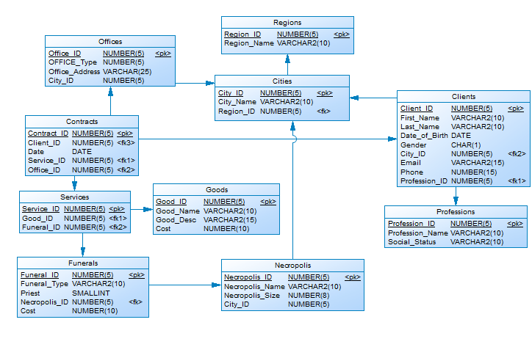

**3.2 Summarize Data plan**

The minimum time period for analyze will be a month. Every month, after loading of data the report satisfying business requirements must be generated.

This reports will show us the sum of all contracts for all offices, analyze of all types of funeral ceremonies, sold products, most popular necropolises, clients information, and etc. On the base of this reports data will be aggregated data for quarters and years.